SKILL DEVELOPMENT REPORT
ELECTRONICS AND COMMUNICATION ENGINEERING (Project Name)
(USN)
DLithe Consultancy Services Pvt. Ltd.
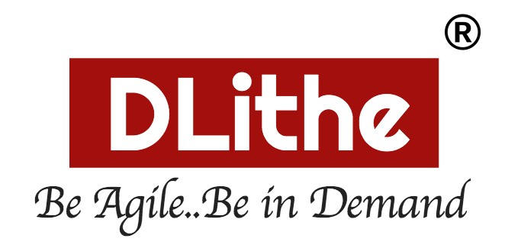

Skill Development Report

Intern Name: Anirudh.S.Parastekar
Reg. no: 4MT21CS024
Job Assignment: Python skill development project Project name :
Organization: DLithe Consultancy Services Pvt. Ltd.
Supervisor’s Name: Ms Sushma

Observations:

Submitted to

Signature of Trainer Signature of Student

Date: Date:

Letter of Transmittal

To,
Program Co-ordinator
DLithe Consultancy Services Bengaluru

Dear Sir/Madam,
We hereby submit the report on the Python Skill Development Activity conducted for the Electronics and Communication Engineering (ECE) Department, as a part of our academic skill enhancement program.
The Python Skill Development Activity provided a valuable learning experience and helped us strengthen our programming fundamentals. The program focused on core Python concepts such as syntax, control structures, functions, data structures, and problem-solving techniques. Emphasis was given to hands-on practice, enabling students to apply theoretical concepts through practical exercises and real-world examples.
Through this activity, students developed improved logical thinking abilities and gained confidence in writing and executing Python programs. The training also highlighted the relevance of Python as a versatile programming language widely used in software development, data analysis, automation, and emerging technological areas applicable to ECE domains.
This report presents a detailed account of the training program, including the topics covered, learning objectives, and outcomes achieved. We believe that the knowledge and skills gained through this activity will be beneficial for our academic progress and future professional development.
We respectfully submit this report for your kind review and consideration.

Sincerely,
Name: Shravya Devadiga
Reg. No: 4MT21CS150

Table of Contents

Sl. No. Content Page No.
- Introduction 1
- Problem Statement 2
- Objectives of the Project 3
- Scope of the Project 4
- Methodology 6
- Flow Chart 7
- Use Case Diagram 8
- Tools and Technologies Used 10 9 Results and Snapshots 11
- Applications 12
- Conclusion 13
- GitHub Repository Link 13
- Mind Map 14

